Day 7 - Java Control Flow Notes

Review Last week

Only one day so far in Java

Here at 5:00 to help

Setup

Create c:/tts/Day 7 - Java Control Flow

Open Eclipse and browse to this directory

New Java Project ControlFlow

New package com.tts

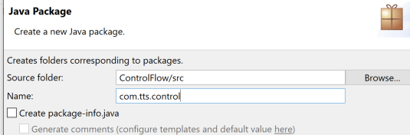

New Class Main

**public** **static** **void** main(String[] args) {

Controller controller = **new** Controller();

controller.helloWorld();

}

New Class Controller

**public** **class** Controller {

**public** **void** helloWorld() {

System.***out***.println("Hello World");

}

}

Run Main as Java Application

Need slide numbers (61 slides)

(Slide 5)

// Create controller method slide5(), call from Main

**public** **void** conditional() {

**int** count = 44;

**if** ( count > 20 )

{

String msg = "Count is large!";

System.***out***.println(msg);

}

**if** ( count > 50 )

{

String msg = "Count is VERY large!";

System.***out***.println(msg);

}

System.***out***.println("Finished checking count.");

// output:

// Count is large!

// Finished checking count.

}

More complex conditional (Slide 10)

**public** **void** CheckId(**boolean** validId, **int** age, **boolean** buyingAlc) {

**if** (validId) {

System.***out***.println("Valid ID presented");

**if** ((age > 21) && (buyingAlc)) {

System.***out***.println("Customer legal to purchase alcohol");

} **else** {

System.***out***.println("No alcohol sales to this person");

}

} **else** {

System.***out***.println("Error: Invalid license");

}

}

Switch statement (slide 18)

// call from main, note the single quote

controller.printShirtSize('s');

**public** **void** printShirtSize(**char** shirt) {

String msg = " ";

**switch** (shirt) {

**case** 's':

msg = "Shirt is small";

**break**;

**case** 'm':

msg = "Shirt is medium";

**break**;

**case** 'l':

msg = "Shirt is large";

**break**;

**case** 'x':

msg = "Shirt is Xtra large";

**break**;

**default**:

msg = "Unknown shirt size";

**break**;

}

System.***out***.println(msg);

}

**TOPIC: break**

Show slide 18 has printShirtSize with breaks.

Show slide 21 has printShirtSize with breaks.

**TOPIC: Looping (Show all these slides and do the following in programs) (End at branching statements)**

// I made this one up for While loop (Slide 32

**public** **void** loop() {

**int** i = 0;

**while** (i < 10) {

System.***out***.println(i++); // try ++1

}

}

// convert to do while version

**public** **void** loop() {

**int** i = 0;

**do** {

System.***out***.println(++i);

} **while** (i < 10);

}

// Read from file (Copy from Slide 35

BufferedReader reader = **new** BufferedReader(**new** FileReader("myTextFile.txt"));

String line = reader.readLine();

**while** (line != **null**)

{

System.***out***.println(line);

line = reader.readLine();

}

// Need to add try catch (look at the errors)

Select code and right click -> surround with -> try catch

// Run and see exception

// Add file Right click -> New -> File (Put in ControlFlow directory

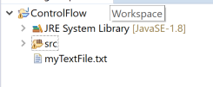

// Review Chart (Slide ??)

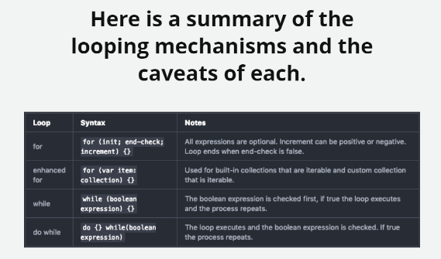

**TOPIC: Branching (Show slides and show code below)**

**// break (slide 41)**

**public** **void** break() {

// generate a random number between 0 and 100

Random random = **new** Random();

**int** breakAt = random.nextInt(100);

// print a 'list' of random length

**for**(**int** i=0; i<100; i++)

{

**if** ( i==breakAt)

{

System.***out***.println("Random number was: " + breakAt);

**break**;

}

System.***out***.println("Index: " + i);

}

System.***out***.println("After the loop");

}

**// alternate break (break only throws you out of inner loop) (Slide 43)**

**public** **void** loop() {

Random random = **new** Random();

**int** breakAt = random.nextInt(100);

**for**(**int** x=1; x<=5; x++)

{

System.***out***.println("Starting list " + x);

**for**(**int** i=0; i<100; i++)

{

**if** ( i==breakAt)

{

System.***out***.println("Length of this list: " + breakAt); // list is a bad term here

**break**;

}

System.***out***.println("Index: " + i);

}

System.***out***.println("Finished list " + x);

// Get the next randome number for a different size list

breakAt = random.nextInt(100);

}

System.***out***.println("After the loop");

}

**// break outer (Slide 46)**

Modify code above to say break outer; and add outer: before for loop. Needed if you need to break out of more than one for loop.

**// Continue (Slide 49)**

**public** **void** continue() {

// generate a random number between 0 and 100

Random random = **new** Random();

**int** breakAt = random.nextInt(100);

// print a 'list' of random length

**for**(**int** i=0; i<100; i++)

{

**if** ( i==breakAt)

{

System.***out***.println("Random number was: " + breakAt);

**break**;

}

// if number is even, skip to next iteration

**if** ( i%2==0)

{

**continue**;

}

System.***out***.println("Index: " + i);

}

System.***out***.println("After the loop");

}

**// Return**

// insert ONLY positive, odd data

**public** **void** insertOddData(**int** data) {

// equal to 0 check

**if** (data == 0) {

**return**;

}

// Negative check

**if** (data < 0) {

**return**;

}

// check to see if data is even or odd

**if** (data % 2 == 0) {

**return**;

}

// some code here to store the odd data somewhere

System.***out***.println("Odd Data Stored");

**return**;

}

//Add to Main

controller.insertOddData(1);

controller.insertOddData(2);

controller.insertOddData(3);

// find and return the sum of the array

**public** **int** getArraySum(**int**[] arr) {

// initialize to a valid default return value

**int** sum = 0;

// array must have values to sum

**if** (arr.length > 0) {

**for** (**int** n : arr) {

sum += n;

}

}

**return** sum;

}

// Add to Main

**public** **static** **void** main(String[] args) {

Controller controller = **new** Controller();

**int**[] intArray = **new** **int**[]{ 1,2,3,4,5,6,7,8,9,10 };

**int** sum = controller.getArraySum(intArray);

System.***out***.println(sum);

}

**// Questions (Slide ??)**

**Control Flow Lab (Show students the document) Give 30 minutes to work on**

// convert string to char

String str = "This is a very long and completely meaningless string that serves no purpose.";

for (int i = 0; i < str.length(); i++) {

System.out.println(str.charAt(i));

}

**Homework**

Do lesson in class, lab and homework from home.

If there is not spot to upload homework then no need to upload anything.